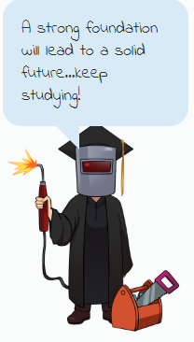 | Career Reflection:  ARCHITECTURE & CONSTRUCTION  Website Link: Dr. Kit’s Career Video Link
Directions: You will visit the website linked above. After reading about this week’s career cluster, you should choose two different career/job videos in that cluster to reflect on. You will watch the entire video for each job. You should be able to answer each of the following questions about each career, based on the information in the video. Your answer should be RED.

#1 - Job/Career Name: | Welding
What are 4 tasks someone doing this job might perform? | Weld multiple different objects together  Find the correct measurements for the job  Make sure everything fits  Fix any errors that they might have
List 2 skills or abilities a person doing this job needs to be able to do. | Math skills  Have the ability to know the measurements
What is the work environment like for this job? | Mostly in the heat
Is this a job you can see yourself doing in the future? Why or why not? (Your answer should be at least 3 complete lines of text in the box on the right.) | No this is not a job I want to do because I do not like the flashing of the lights and I dont have the patience to do this job in all of the weather conditions.

#2 - Job/Career Name: | Carpenter
What are 4 tasks someone doing this job might perform? | Use power tools  Measuring tapes  Build building  Sand wood
List 2 skills or abilities a person doing this job needs to be able to do. | Math skills  Have the ability to know measurements  Have the ability to do the work
What is the work environment like for this job? | Everywhere inside and outside
Is this a job you can see yourself doing in the future? Why or why not? (Your answer should be at least 3 complete lines of text in the box on the right.) | I could see myself doing this job because I like to build with wood and I also like to be outside doing whatever

