Chapter 17: Personal Selling Name:_______________________________________
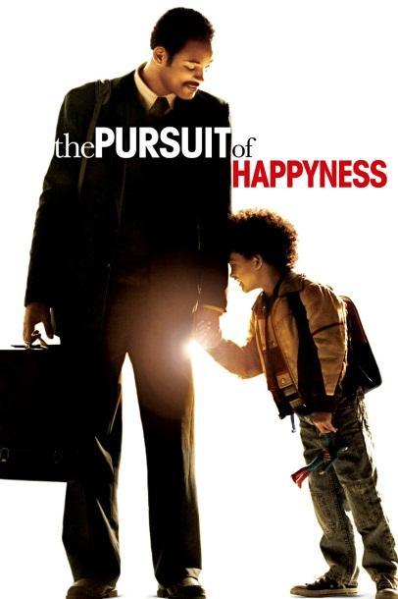
Video: The Pursuit of Happiness

The movie you will be watching stars actor Will Smith and his son Jaden. This is an inspirational true story about Chris Gardner, a San Francisco salesman who struggles to make ends meet. After his wife leaves him, Chris Gardner is left alone to raise his 5-year old son. With little money, this single father and his son become homeless.
Chris’s determination to succeed pays off when he lands an unpaid internship experience that could lead to his dream job of becoming a stockbroker.

Directions: As you watch the movie please answer each of the following questions in the space provided on this paper.

1. In San Francisco in 1981 Chris Gardner is a salesman. What “device” does Chris sell for a living?

_____________________________________________________________________________

2. Chris is riding the bus in order to visit potential customers. What is another name for a potential customer? We discussed this in class.

__________________________________

3. In his first meeting in the movie with a potential customer we clearly hear the potential customer state two objections. What are those objections? (One is the most common objection in sales.)

_____________________________________________________________________________

4. According to the man in the red convertible sports car, what does it take to be a stockbroker?

_____________________________________________________________________________

5. Chris applies for an internship program to become a stockbroker. What is an internship program?

_____________________________________________________________________________

6. When Chris went to his internship interview he was inappropriately dressed and covered in white paint. How did Chris turn this disadvantage into a positive thing?

_____________________________________________________________________________

7. On the first day of his internship Chris and the other interns are told that they will be “cold calling” on clients in the financial district. Where will the interns get the prospect information needed to make these sales calls?

_____________________________________________________________________________

8. Describe a well-qualified prospect for the sale financial services?

_____________________________________________________________________________
9. Chris missed his appointment with the pension fund CEO Walter Ribbon. The next day Chris went to his home and managed to get an invitation to the 49er’s game. Why did Chris travel to the home of his prospect?

_____________________________________________________________________________

10. As he is leaving the football game, several businessmen are giving Chris their business cards. This is an example of finding additional ….

_____________________________________________________________________________

11. Later Chris demonstrates his ability to sit down with clients and interact they them. How would you describe Chris’s ability to communicate with potential customers?

_____________________________________________________________________________

12. Why do you believe Chris won the job as a stockbroker?

_____________________________________________________________________________

13. What characteristics does Chris Gardner have that all salespeople should have in order to be successful? These characteristics are important to success in any career.

_____________________________________________________________________________

_____________________________________________________________________________

Follow-up:

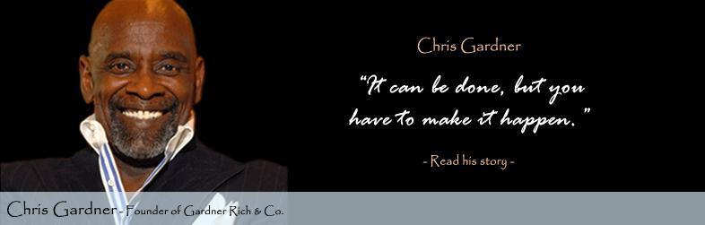
Chris is a successful American entrepreneur, investor, stockbroker, motivational speaker, author, and philanthropist. As of 2013, Chris is the CEO of his own stockbrokerage firm, Gardner Rich & Co, based in Chicago, Illinois, where he resides when he is not living in Toronto. Gardner credits his tenacity and success to the "spiritual genetics" handed down to him by his mother, Bettye Jean Triplett, and to the high expectations placed on him by his children, son Chris Jr. (born 1981) and daughter Jacintha (born 1985).

