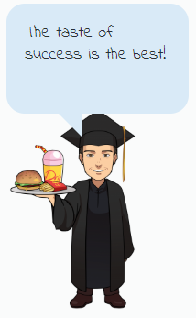 | Career Reflection:  HOSPITALITY & TOURISM  Website Link: Dr. Kit’s Career Video Link
Directions: You will visit the website linked above. After reading about this week’s career cluster, you should choose two different career/job videos in that cluster to reflect on. You will watch the entire video for each job. You should be able to answer each of the following questions about each career, based on the information in the video. Your answer should be RED.

#1 - Job/Career Name:
What are 4 tasks someone doing this job might perform? | 1.  2.  3.  4.
List 2 skills or abilities a person doing this job needs to be able to do. | 1.  2.
What is the work environment like for this job?
Is this a job you can see yourself doing in the future? Why or why not? (Your answer should be at least 3 complete lines of text in the box on the right.)

#2 - Job/Career Name:
What are 4 tasks someone doing this job might perform? | 1.  2.  3.  4.
List 2 skills or abilities a person doing this job needs to be able to do. | 1.  2.
What is the work environment like for this job?
Is this a job you can see yourself doing in the future? Why or why not? (Your answer should be at least 3 complete lines of text in the box on the right.)

