16 Career Cluster Video Reflection:
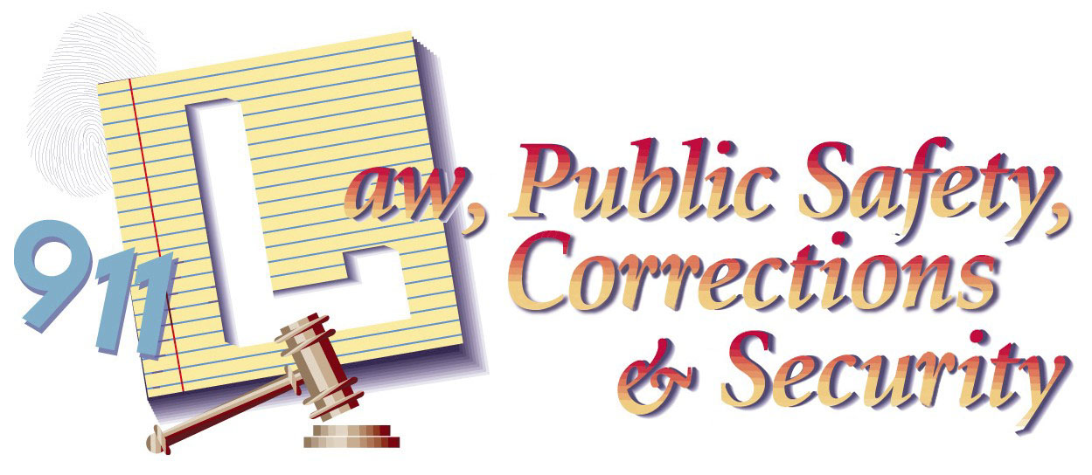
Law, Public Safety & Security

Name:

Video Link: What’s Your Plan?

Video Analysis: Type one complete sentence about six different things/facts that you learned in the video about the career cluster. These should be six things that stand out to you as you watch the video. The things you write about should span the entire video, and you MUST watch the entire video.
1. | 4.
2. | 5.
3. | 6.

Video Reflection: After watching this video write about a job or jobs in this cluster that you think would be for a good job for you. Give example of the type of jobs that are the most interesting to you. If you do not think any jobs in this cluster would be good for you, tell why. Your answer should be 3-5 sentences.

