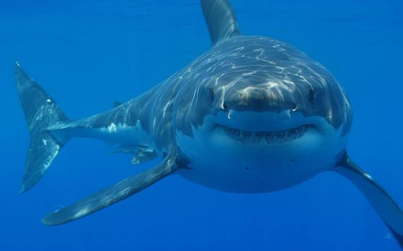
Shark Tank Worksheet
Season:
Episode:
Company Name:

Starting Valuation:
Offer(s) Valuation:

What does the product sell for? $___________
-
What is the cost to make it? $___________
=
Profit Margin $___________

Business Plan Details:

What are they planning on doing with the money the sharks give them? (i.e. Marketing, hiring, inventory, capacity planning, business analytics)

How will the Sharks get their money back? How long will it take? Explain your answer with numbers.

